System Design Document: Enterprise Knowledge Assistant
Overview
The Enterprise Knowledge Assistant is a Retrieval Augmented Generation (RAG) system designed to answer natural language questions over enterprise documents such as product documentation, HR policies, technical guides, FAQs, process documents, and compliance files. The goal of the system is to reduce manual document search time by retrieving relevant information from indexed documents and generating grounded answers with source references.
The system is implemented as a lightweight but modular architecture using FastAPI for backend APIs, FAISS for vector search, Google Gemini for answer generation, and Streamlit for the user interface. This design was chosen to balance simplicity, clarity, and production-oriented engineering practices within the assignment scope.
Architecture Diagram
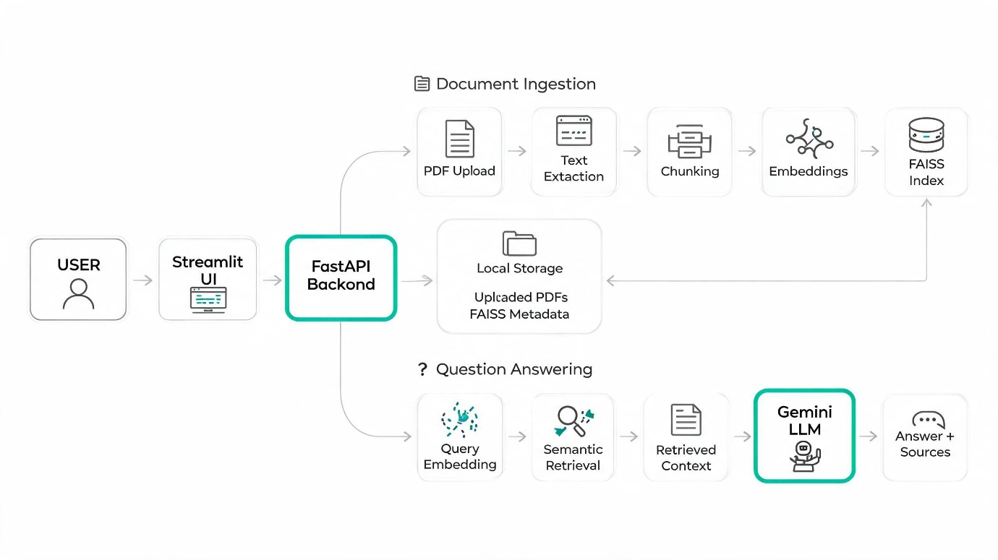
High-Level Architecture
The system is composed of four major layers:
1. User Interface Layer
A Streamlit application provides a simple interface for:
- Uploading PDF documents
- Asking questions in natural language
- Viewing generated answers
- Viewing source references when available
2. API Layer
FastAPI exposes the core backend functionality through API endpoints:
- POST /upload/ for document upload and ingestion
- POST /ask for question answering
This API-first design allows the assistant to be used both through the UI and programmatically.
3. Processing and Retrieval Layer
This layer contains the core document and query processing services:
- PDF extraction
- Text chunking
- Metadata attachment
- Embedding generation
- Semantic retrieval from FAISS
4. Generation and Storage Layer
This layer contains:
- FAISS index for storing document embeddings
- Chunk metadata storage
- Gemini-based answer generation
- Local file storage for uploaded PDFs and index files
Data Flow
Document Ingestion Flow
- A user uploads a PDF through the Streamlit UI or the /upload/ API.
- The backend stores the uploaded file in a local upload directory.
- The PDF extraction service reads the file and extracts text.
- The chunking service splits the extracted text into smaller passages.
- Metadata is attached to each chunk, such as document name and page placeholder.
- The embedding service converts each chunk into a vector representation.
- The FAISS service creates or updates the vector index with the new embeddings.
- Chunk metadata is stored alongside the FAISS index for later retrieval.
This flow transforms raw documents into searchable semantic knowledge units.
Question Answering Flow
- A user submits a question through the Streamlit UI or /ask API.
- The backend loads the FAISS index and chunk metadata.
- The embedding service converts the user question into a query embedding.
- The retrieval service performs top-k similarity search in FAISS.
- The most relevant chunks are selected as context.
- The LLM service constructs a prompt using only the retrieved context.
- Gemini generates an answer based on that context.
- The backend returns:
  - the final answer,
  - source document reference,
  - page number if available,
  - optional confidence value.
- The UI displays the answer and source references.
This flow ensures that the answer is retrieval-grounded rather than purely model-generated.
Component Explanation
main.py
Initializes the FastAPI application and registers routes.
routes/upload.py
Handles PDF upload requests. It saves files, extracts text, chunks content, generates embeddings, and stores them in FAISS.
routes/query.py
Handles user questions. It loads indexed data, retrieves top matching chunks, calls the LLM service, and formats the response.
services/pdf_service.py
Extracts text from uploaded PDF documents.
services/chunk_service.py
Splits extracted text into smaller chunks suitable for retrieval. Chunking improves retrieval precision by preventing the model from operating on entire large documents.
services/embedding_service.py
Generates embeddings for both document chunks and user questions so they can be compared in the same vector space.
services/faiss_service.py
Creates, loads, saves, and updates the FAISS vector index. It also manages stored chunk metadata.
services/retrieval_service.py
Performs semantic search by retrieving top-k similar chunks from the FAISS index.
services/llm_service.py
Builds the grounded prompt and invokes Gemini to generate a concise answer using only retrieved context. It also handles fallback behavior such as returning “I don't know based on the available documents.” when the answer is unsupported.
frontend/app.py
Implements the UI for uploading documents, asking questions, and rendering answers and sources.
Design Rationale
The architecture is intentionally modular so that document ingestion, retrieval, generation, and presentation are separated into independent components. This improves readability, maintainability, and extensibility.
FAISS was selected because it is lightweight, fast, and easy to integrate for local semantic search. FastAPI was chosen because the assignment prefers an API and because it provides clean service endpoints. Streamlit was selected for rapid development of a user-facing interface. Gemini was used as the LLM because it integrates well for concise answer generation and supports prompt-controlled grounded responses.
Scalability Considerations
Although the current implementation is a prototype, the design can be extended for production use.
1. Vector Database Scaling
The current FAISS index is stored locally, which is sufficient for small- to medium-sized datasets. For larger enterprise deployments, the system can migrate to a managed vector database such as Pinecone, Weaviate, or ChromaDB.
2. Asynchronous Ingestion
Currently, document ingestion happens synchronously during upload. For large files or large document collections, ingestion should be moved to background jobs using tools such as Celery or task queues.

3. Better Metadata Management
The current prototype stores document-level citations reliably, but page-level citation is only partially preserved. A stronger production version should maintain exact page mappings during PDF extraction and chunk creation.
4. Improved Retrieval Quality
The current retrieval strategy uses semantic top-k retrieval only. This can be improved by:
- hybrid search (keyword + semantic),
- re-ranking retrieved chunks,
- query rewriting,
- better chunk scoring.
These are also aligned with the bonus features mentioned in the assignment.
5. Security and Multi-User Support
A real enterprise deployment would require:
- authentication,
- authorization,
- user-specific document access,
- audit logging,
- secure API key handling.
6. Reliability and Monitoring
A production-ready version should include:
- structured logging,
- error monitoring,
- retry handling,
- rate limiting,
- health checks,
- usage analytics.
Conclusion
The Enterprise Knowledge Assistant demonstrates a practical RAG architecture that supports document ingestion, semantic retrieval, grounded answer generation, and source-aware responses. The current implementation is intentionally simple to fit the assignment scope, but it follows a modular design that can be extended for better metadata management, improved retrieval quality, and production-scale deployment.

